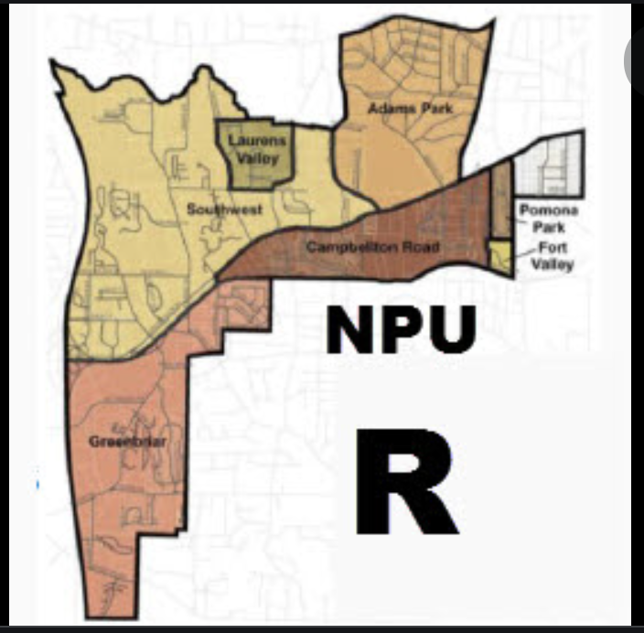

NPUR Atlanta March 2, 2022

Meeting minutes
Location: Zoom Call
Date: Wednesday, March 2, 2022
Attendees: 54
Time: 7PM till 8:30PM

Action Items

- Z-22-07 Support to Defer
9 Support, 0 Deny, 1 Abstention
- Z-22008 Support To Defer
9 Support, 0 Deny, 1 Abstention.
- Community Impact Grant
5 Support, 4 Deny, 4 Abstentions

